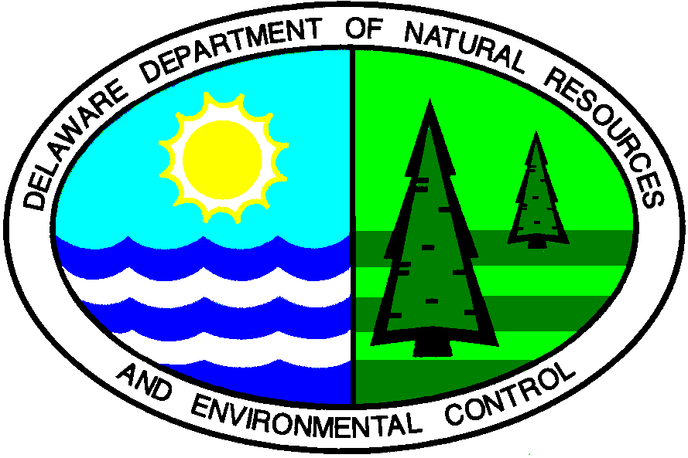

State of Delaware
Department of Natural Resources & Environmental Control
Division of Water Resources
Ground Water Discharges Section

Innovative and Alternative System Approval

ISSUED TO: Jet Inc.
750 Alpha Drive
Cleveland, Ohio 44143

Phone (440) 461-2000
Fax (440) 422-9008
email@Jetincorp.com

FROM: Hilary Moore – Environmental Engineer
Ground Water Discharges Section

FOR: Jet Inc. J-500 CF Advanced Treatment Unit

APPROVAL DATE: May 4, 2009

In accordance with the Regulations Governing the Design, Installation, and Operation of On-Site Wastewater Treatment and Disposal Systems (Regulations), an application dated April 8, 2009, has been submitted by Jet Inc., for approval of the Jet J-500 CF Advanced Treatment Unit as an Innovative & Alternative On-Site Wastewater Treatment System.

Based on the review of the application, the Department hereby grants approval of the use of the treatment unit. The following conditions, limitations, and requirements must be adhered to:

- Product Description

The Jet Inc. Model J-500 CF Advanced Treatment Unit utilizes a dual process biological system. The system uses activated sludge process in conjunction with an attached growth process to achieve biological treatment.

There are three basic zones for treatment. Primary treatment occurs in the pretreatment zone. This zone reduces the amounts of solids entering the biological treatment zone.

From the pretreatment zone, the water passes through a submerged orifice into a biological treatment zone which houses the plastic media. The plastic media allows for a fixed film reactor to function in conjunction with a conventional activated sludge process. The media is completely submerged. Aeration is provided by a central aspirate that produces enough oxygen for the suspended growth and fixed film. The aeration unit draws air down the center shaft and creates small bubbles which are mixed throughout the compartment. The aerator operates on a timed cycle in order to reduce the nitrogen in the system.

Clarification occurs in the final compartment which allows for settable solids to be removed from the clear effluent and returned by gravity to the aeration zone. The aeration zone allows the solids to be drawn from the clarifier back into suspension in the biological reactor. This occurs along the entire width of the unit though a slot at the bottom of the compartment. A final effluent filter is installed to remove additional particles from the effluent prior to exiting the tank.

2. Claim

Approval is based on information submitted by the Manufacturer indicating the specified model will routinely provide effluent quality not exceeding a monthly average of 30 mg/l of BOD₅; 30 mg/l of TSS; and 20 mg/l of Total Nitrogen (TN) (or 50% reduction) assuming influent loading does not exceed the treatment capabilities of the units.

- Scope of Use

The advanced treatment unit may be used for residential waste with flows <500 gallons per day. Other usages will be on a case by case basis.

4. Use and Design Criteria

    - The. J-500 CF Advanced Treatment Unit may be installed for new and replacement systems with conventional and innovative and alternative disposal systems.
    - The. J-500 CF Advanced Treatment Unit shall be installed in a tank approved by DNREC.
    - An on-site wastewater treatment and disposal system permit application incorporating a J-500 CF Advanced Treatment Unit shall be designed in accordance with the Regulations, and manufacturer’s specifications. The design shall be completed by a DNREC Class C Design Engineer unless otherwise approved by the Department. The permit application shall include proper unit specifications.
    - The designer must assure that the pretreatment zone, treatment zone, and settling zone all have above grade access. The design also must ensure that the control panel and blower are accessible.
    - The J-500 CF Advanced Treatment Unit shall not be installed within areas subject to traffic loads unless specially designed on a case by case basis in accordance with the Regulations and in accordance with manufacturer’s specifications.
    - The timer shall be set to 30 minute on/off cycles as per manufacturer’s recommendations.
    - A Zabel A-300-8X18, or manufacturer equivalent approved by DNREC effluent filter must be installed as part of this system

5. Installation Procedures

- The J-500 CF Advanced Treatment Unit shall be installed by a DNREC Class E System Contractor under the supervision of a manufacturer’s representative, or by a DNREC Class E System Contractor who has been certified for unit installation. Proof of certification shall be provided in writing to the Department.
- Start up of the system and initial operational checks shall be conducted by the Class E System Contractor (trained by the manufacturer), Design Engineer, and a Ground Water Discharges Section (Large System Branch) representative. If the Class E System Contractor is not certified, a manufacturer’s representative shall perform the operational checks of the system at start up. If the manufacturer’s representative cannot be on site at the time of start up, they must provide final start up approval to the Department in writing.

- Operation and Maintenance

- The J-500 CF Advanced Treatment Unit shall be operated and maintained in accordance with the manufacturer’s specifications.
- The manufacturer shall comply will all Department mandated
requirements as specified in permit conditions. This shall include operation and maintenance requirements.

- Sampling and Approval

The Department reserves the right to sample any unit at any time.

- General Conditions

    - Use of the system for wastes other than residential shall be on a case by case basis.
    - In the event that the product fails to perform as claimed by the applicant, the use of the units for new installations shall cease. Use of the units shall not resume until such time the applicant and the Department have reached an acceptable agreement for resolving the situations.
    - Any changes that deviate from the specifications as submitted with this approval shall be approved by the Department prior to use.
    - The manufacturer is responsible for providing the Department a list of all local distributors and certified service providers, and their associated contact information. This list must be kept current and shall be submitted to the Department on a yearly basis.

